North Point Government Primary A.M. School
First Term English Supplementary Worksheet
Unit3: Listen to the teacher

Class: P.1( ) Name:__________________( ) Date:_____________

- Susan is going into an animal classroom. She is teaching the animals. Find out which animal is doing right and put a () in the brackets.
1.
2.
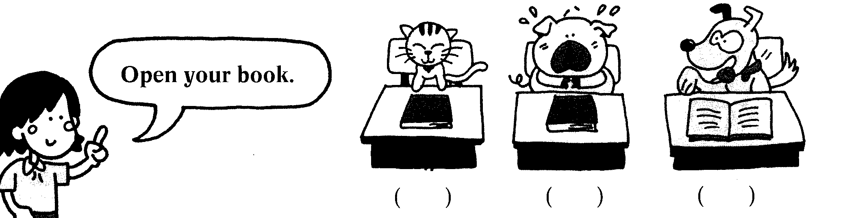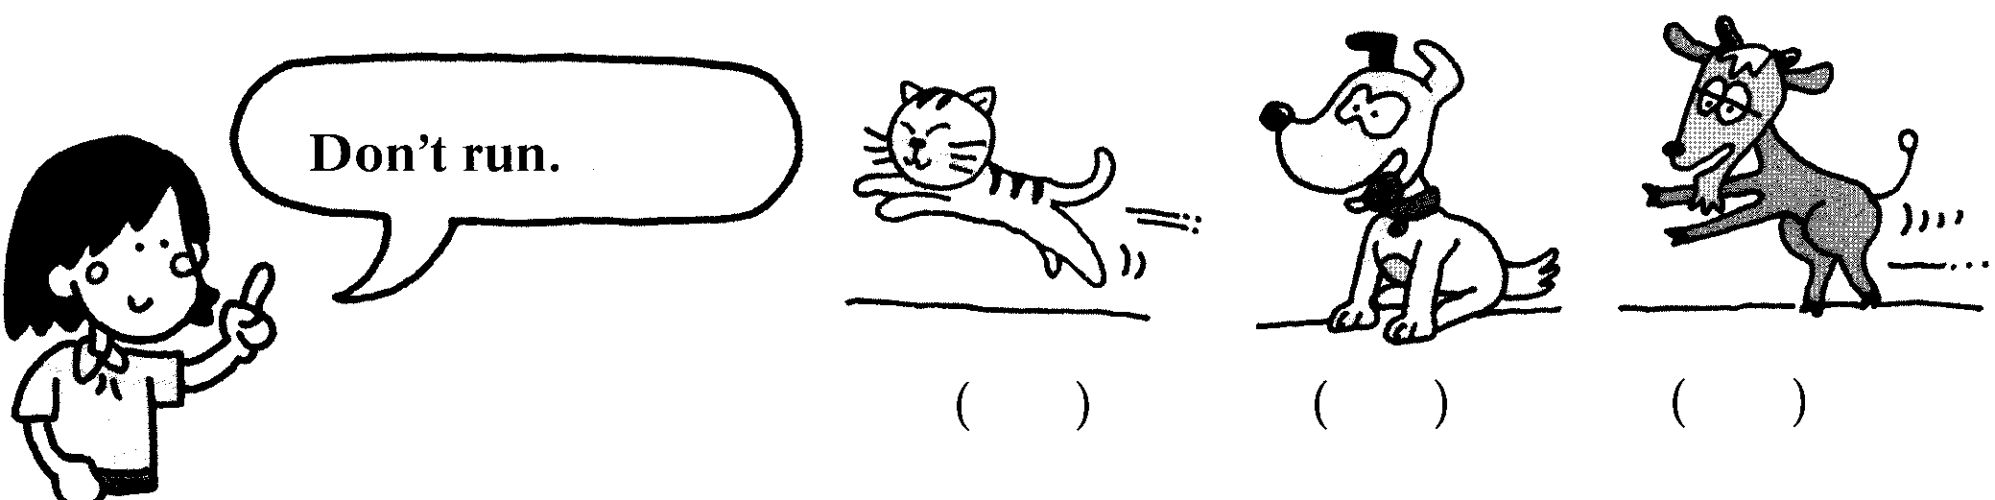
3.
4.
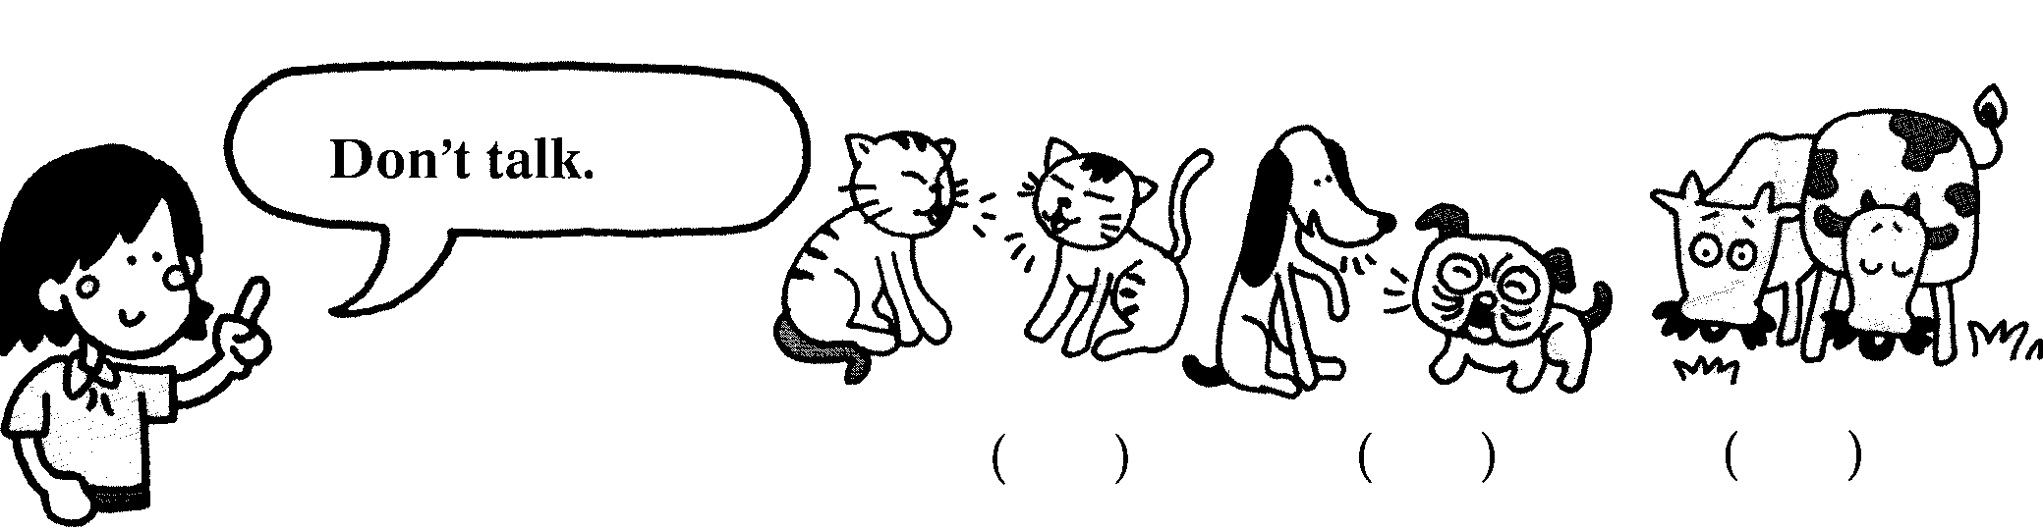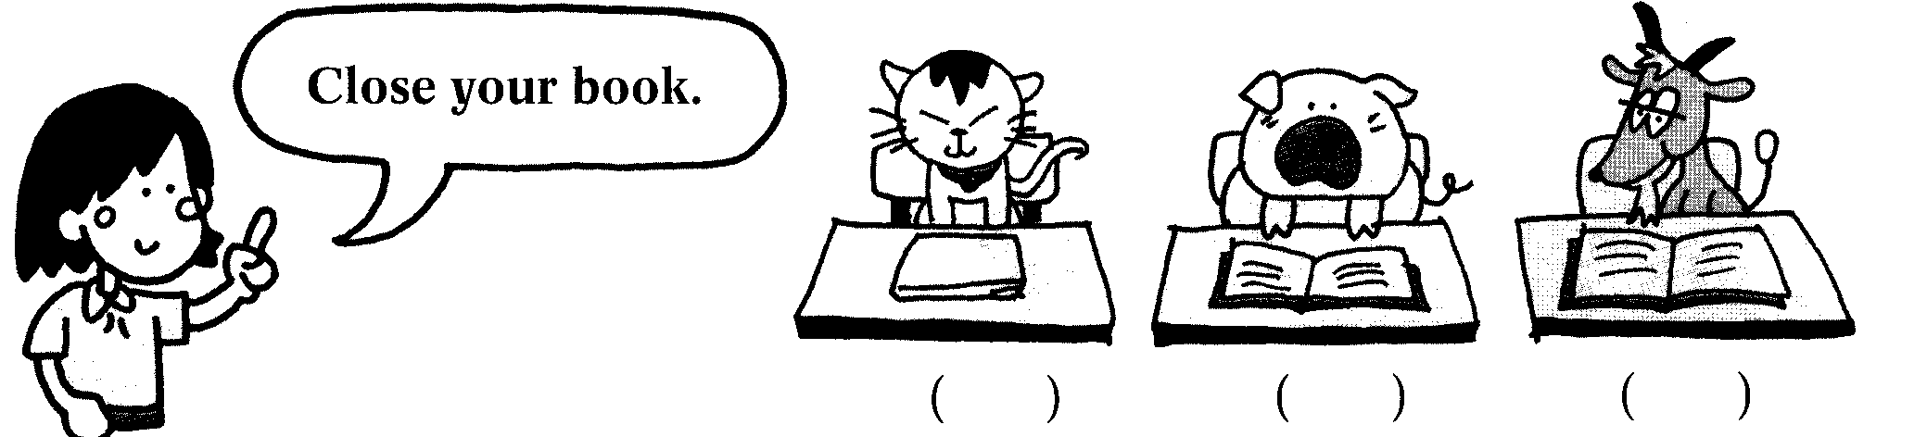

B. What are they saying? Choose and write.

Open the door. | Don’t stand up
Sit down | Point to the window

